Hello everyone,
Here are some revision exercises for Present Simple and Present Continuous!!
First, study the following grammar box and the grammar rules below!

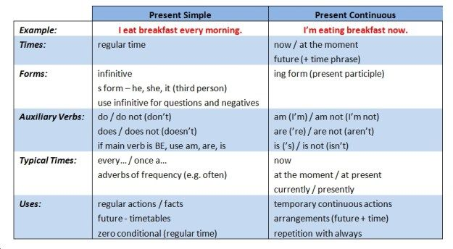
*regular = τακτικός * currently, presently = τώρα , προς το παρόν
* infinitive = απαρέμφατο *temporary actions = προσωρινές πράξεις
* auxiliary verbs = βοηθητικά ρήματα * timetables= δρομολόγια
* zero conditional – μηδέν υποθετικός * repetition = επανάληψη

Grammar Rule

Examples
I play tennis every Sunday.
I’m playing hockey now.
She eats fruit every day.
She’s eating an apple now.

Remember!
We use the present simple to talk about routines – what you do every day or every week. We use the present continuous to talk about things you are doing now.
I watch cartoons every day.
I’m watching a film now.

Be careful!
For the present simple, add ‘s’ or ‘es’ for he/she/it. Make the negative with ‘don’t’ or ‘doesn’t’. For the present continuous, use the verb ‘to be’ and ‘-ing’. Add ‘not’ to make the negative.
My dad makes dinner every evening. He doesn’t make lunch.
We are studying English now. We aren’t studying maths.

Now watch the following video on you tube:

https://youtu.be/OsW5sV3GMDM

Finally, complete the following sentences using the verbs in the correct tense:

- Every Monday, Sally _____________ (drive) her kids to football practice.
- She usually ___________ (work) as a secretary in a company but this summer she ____________ (study) French at a language school in Paris.
- Shhhh!!! Be quiet!! The baby ________________ (sleep)!!
- Don’t forget to take your umbrella. It ______________ (rain).
- I hate living in Seattle because it ________________ (always/rain).
- I’m sorry I can’t hear what _____________ (say) because everybody ____________ (talk) so loudly!
- Mary: Do you want to come over for dinner tonight?
Jim: Oh I’m sorry I can’t. I ___________ (go) to a movie tonight with same friends.
- This bakery _________________ (usually/make) delicious chocolate cakes but today it ________________ (bake) only apple pies.
- ______________ (have/often) basketball practice every Sunday? Yes, I _________.
- ______________ (she/study) for the Maths test at the moment? No, she ________.
- My mother ________________ (not cook) in the mornings because she must be at work very early.
- You ____________________ (not/listen) to your father!!He is trying to talk to you!!

